TRƯỜNG ĐẠI HỌC TÀI NGUYÊN VÀ MÔI TRƯỜNG

THÀNH PHỐ HỒ CHÍ MINH

KHOA CÔNG NGHỆ THÔNG TIN

**TỔNG HỢP LAB LẬP TRÌNH DI ĐỘNG**

Giảng viên hướng dẫn: **ThS. Phạm Trọng Huynh**

Sinh viên thực hiện: **Nguyễn Ngọc Mỹ Dung**

Mã số sinh viên: 1150080006

Lớp**: ĐH_11_THMT**

Khoá**: 2025 - 2026**

***TP. Hồ Chí Minh, tháng 12, năm 2025***

TRƯỜNG ĐẠI HỌC TÀI NGUYÊN VÀ MÔI TRƯỜNG

THÀNH PHỐ HỒ CHÍ MINH

KHOA CÔNG NGHỆ THÔNG TIN

**TỔNG HỢP LAB LẬP TRÌNH DI ĐỘNG**

Giảng viên hướng dẫn: **ThS. Phạm Trọng Huynh**

Sinh viên thực hiện: **Nguyễn Ngọc Mỹ Dung**

Mã số sinh viên: 1150080006

Lớp**: ĐH_11_THMT**

Khoá**: 2022 - 2026**

***TP. Hồ Chí Minh, tháng 12, năm 2025***

**MỤC LỤC**

BUỔI THỰC HÀNH 1 1

I. BÀI 1 1

1.1. Tạo app có chức năng của một máy tính, có các phép +, -, *, /, % 1

1.2. Tạo app có Camera 4

2.1. Viết chương trình cho phép gọi, nhắn tin trên Hệ điều hành Android. 7

III. BÀI 2 8

1.5. Tạo ứng dụng Animal sound 8

1.6. Tạo giao diện loading 12

1.7. Lập trình để khi bấm vào icon thì chuyển về cuộc gọi, sử dụng Intent. 14

BUỔI THỰC HÀNH 2 18

2. BÀI 3 18

1.1. Tạo chức năng On/Off xoay màn hình 18

1.2. Tạo ứng dụng đọc truyện bằng nhiều ngôn ngữ 18

3. BÀI 4 22

1.1. Tạo 1 ứng dụng Login 22

2.1. Tạo 1 ứng dụng English Learning 24

2.2. Tạo 1 ứng dụng Emoij 26

4. BÀI 5 28

3.1. Tạo 1 ứng dụng Animation 28

3.2. Tạo 1 ứng dụng Quick Call 31

BUỔI THỰC HÀNH 3 35

5. BÀI 6 35

1.1. Tạo ứng dụng đổi tiền tệ 35

1.2. Tạo ứng dụng đổi đơn vị 35

6. BÀI 7 37

2.1. Sử dụng Custom Button 37

3.1. Kết hợp thêm Custom Toast và Custom Dialog 38

4.1. Viết chương trình cho phép chọn màu RGB và màu CMY 40

7. BÀI 8 43

5.1. Xây dựng chương trình hiển thị và quản lý các món ǎn 43

BUỔI THỰC HÀNH 4 48

8. BÀI 9 48

1.1. Tạo ứng dụng biểu đồ 48

3.1. Tạo ứng dụng cuộc đua kì thú 53

9. BÀI 10+11 58

3.2. Tạo ứng dụng truyện cổ tích 58

3.3. Tạo úng dụng truyện cung hoàng đạo 61

BUỔI THỰC HÀNH 5 65

10. BÀI 13+14 65

# BUỔI THỰC HÀNH 1

## BÀI 1

* 1. Tạo app có chức năng của một máy tính, có các phép +, -, *, /, %

**MayTinhActivity**

package com.example.lap01;  
  
import androidx.appcompat.app.AppCompatActivity;  
import android.os.Bundle;  
import android.view.View;  
import android.widget.*;  
public class MainActivity extends AppCompatActivity {  
  
 EditText txtX, txtY;  
 TextView txtResult;  
 Button btnAdd, btnSub, btnMul, btnDiv, btnMod;  
  
 @Override  
 protected void onCreate(Bundle savedInstanceState) {  
 super.onCreate(savedInstanceState);  
 setContentView(R.layout.*activity_main*);  
 initControl();  
 }  
  
 private void initControl() {  
 txtX = findViewById(R.id.*txtX*);  
 txtY = findViewById(R.id.*txtY*);  
 txtResult = findViewById(R.id.*txtResult*);  
  
 btnAdd = findViewById(R.id.*btnAdd*);  
 btnSub = findViewById(R.id.*btnSub*);  
 btnMul = findViewById(R.id.*btnMul*);  
 btnDiv = findViewById(R.id.*btnDiv*);  
 btnMod = findViewById(R.id.*btnMod*);  
  
 View.OnClickListener listener = v -> {  
 try {  
 double x = Double.*parseDouble*(txtX.getText().toString());  
 double y = Double.*parseDouble*(txtY.getText().toString());  
 double result = 0;  
  
 int id = v.getId();  
 if (id == R.id.*btnAdd*) {  
 result = x + y;  
 } else if (id == R.id.*btnSub*) {  
 result = x - y;  
 } else if (id == R.id.*btnMul*) {  
 result = x * y;  
 } else if (id == R.id.*btnDiv*) {  
 result = y != 0 ? x / y : 0;  
 } else if (id == R.id.*btnMod*) {  
 result = x % y;  
 }  
  
 txtResult.setText("Kết quả: " + result);  
 } catch (Exception e) {  
 txtResult.setText("Vui lòng nhập số hợp lệ!");  
 }  
 };  
  
 btnAdd.setOnClickListener(listener);  
 btnSub.setOnClickListener(listener);  
 btnMul.setOnClickListener(listener);  
 btnDiv.setOnClickListener(listener);  
 btnMod.setOnClickListener(listener);  
 }  
}

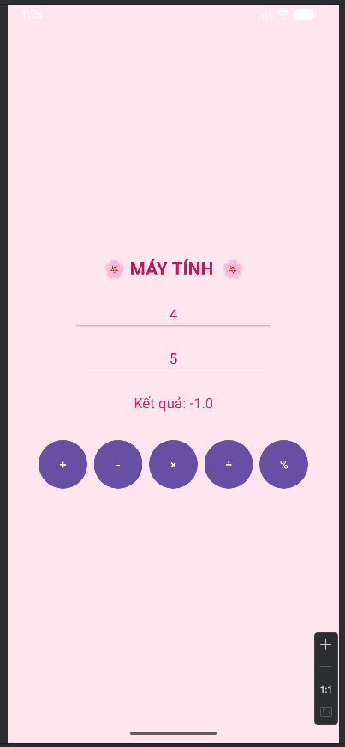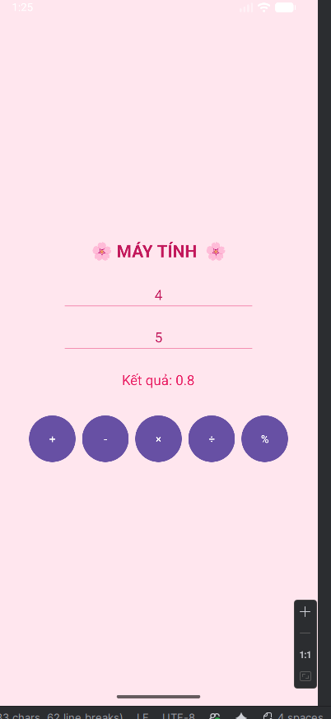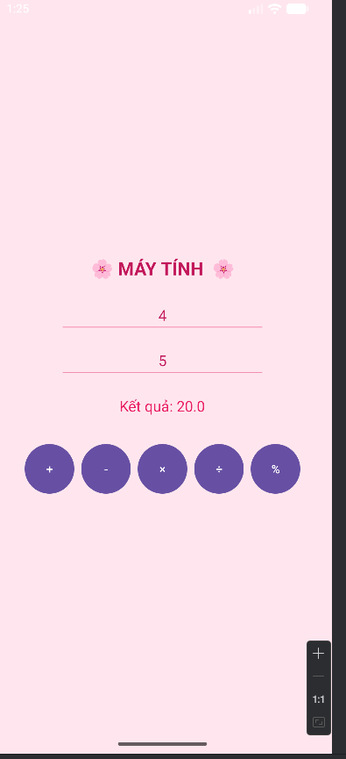 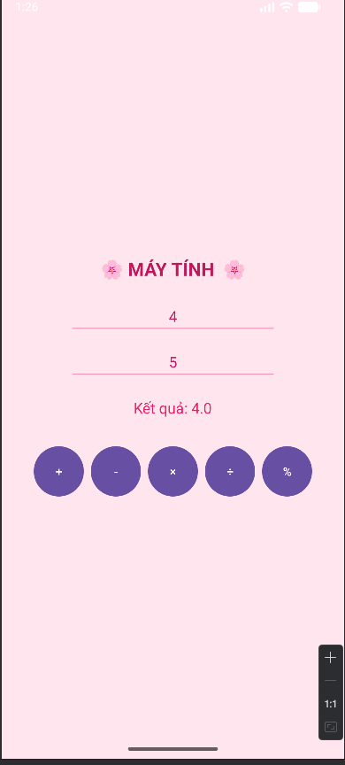

* 1. Tạo app có Camera

1. package com.example.lap01;  
     
   import androidx.activity.result.ActivityResult;  
   import androidx.activity.result.ActivityResultCallback;  
   import androidx.activity.result.ActivityResultLauncher;  
   import androidx.activity.result.contract.ActivityResultContracts;  
   import androidx.appcompat.app.AppCompatActivity;  
   import androidx.core.content.ContextCompat;  
   import android.Manifest;  
   import android.content.Intent;  
   import android.content.pm.PackageManager;  
   import android.graphics.Bitmap;  
   import android.os.Bundle;  
   import android.provider.MediaStore;  
   import android.widget.Button;  
   import android.widget.ImageView;  
   import android.widget.Toast;  
     
   public class CameraActivity extends AppCompatActivity {  
     
    Button btnCamera;  
    ImageView imgPhoto;  
    ActivityResultLauncher<Intent> cameraLauncher;  
    ActivityResultLauncher<String> requestPermissionLauncher;  
     
    @Override  
    protected void onCreate(Bundle savedInstanceState) {  
    super.onCreate(savedInstanceState);  
    setContentView(R.layout.*activity_camera*);  
     
    btnCamera = findViewById(R.id.*btnCamera*);  
    imgPhoto = findViewById(R.id.*imgPhoto*);  
     
    // Initialize the ActivityResultLauncher for the camera  
    cameraLauncher = registerForActivityResult(  
    new ActivityResultContracts.StartActivityForResult(),  
    result -> {  
    if (result.getResultCode() == *RESULT_OK* && result.getData() != null) {  
    Bundle extras = result.getData().getExtras();  
    Bitmap imageBitmap = (Bitmap) extras.get("data");  
    imgPhoto.setImageBitmap(imageBitmap);  
    }  
    });  
     
    // Initialize the ActivityResultLauncher for permission requests  
    requestPermissionLauncher = registerForActivityResult(  
    new ActivityResultContracts.RequestPermission(),  
    isGranted -> {  
    if (isGranted) {  
    // Permission is granted, launch the camera  
    launchCamera();  
    } else {  
    // Permission is denied  
    Toast.*makeText*(this, "Camera permission is required to use the camera", Toast.*LENGTH_SHORT*).show();  
    }  
    });  
     
    // When the button is clicked, check for permission and launch the camera  
    btnCamera.setOnClickListener(v -> {  
    checkCameraPermissionAndLaunch();  
    });  
    }  
     
    private void checkCameraPermissionAndLaunch() {  
    if (ContextCompat.*checkSelfPermission*(  
    this, Manifest.permission.*CAMERA*) ==  
    PackageManager.*PERMISSION_GRANTED*) {  
    // You can use the API that requires the permission.  
    launchCamera();  
    } else {  
    // You can directly ask for the permission.  
    requestPermissionLauncher.launch(Manifest.permission.*CAMERA*);  
    }  
    }  
     
    private void launchCamera() {  
    Intent intent = new Intent(MediaStore.*ACTION_IMAGE_CAPTURE*);  
    cameraLauncher.launch(intent);  
    }  
   }

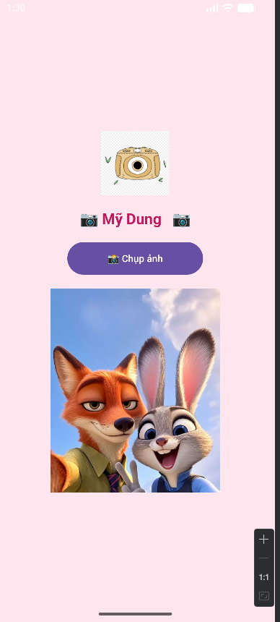 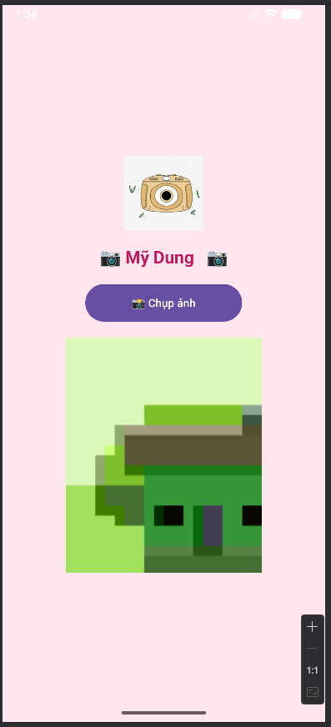 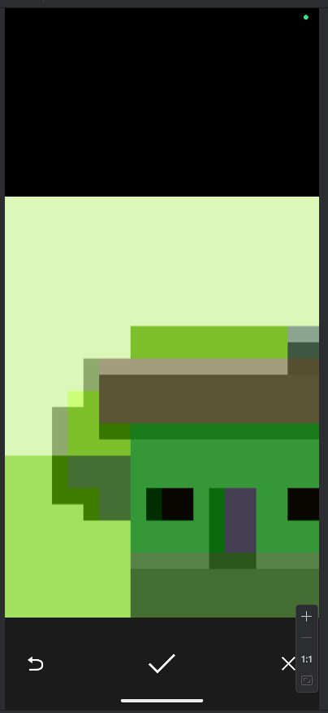

**XucXacActivity**

package com.example.lap01;  
  
import androidx.appcompat.app.AppCompatActivity;  
import android.os.Bundle;  
import android.widget.*;  
import java.util.Random;  
  
public class RandomActivity extends AppCompatActivity {  
 ImageView imgDice;  
 TextView tvResult;  
 Button btnRoll;  
 Random random = new Random();  
  
 @Override  
 protected void onCreate(Bundle savedInstanceState) {  
 super.onCreate(savedInstanceState);  
 setContentView(R.layout.*activity_random*);  
  
 imgDice = findViewById(R.id.*imgDice*);  
 tvResult = findViewById(R.id.*tvResult*);  
 btnRoll = findViewById(R.id.*btnRoll*);  
  
 btnRoll.setOnClickListener(v -> {  
 int num = random.nextInt(6) + 1;  
 tvResult.setText("Bạn tung được: " + num + " 🎉");  
  
 int resId = getResources().getIdentifier("dice" + num, "drawable", getPackageName());  
 imgDice.setImageResource(resId);  
 });  
 }  
}

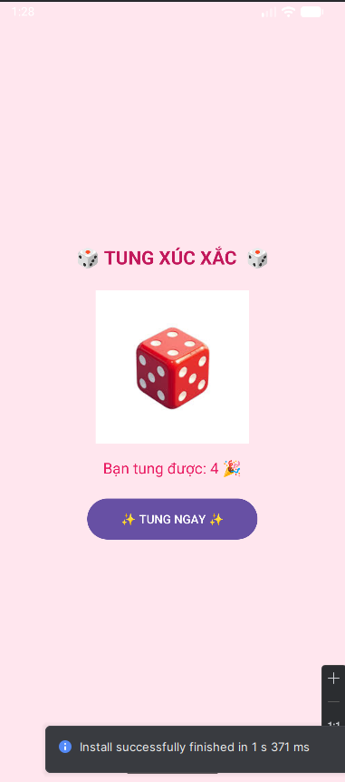

* 1. Viết chương trình cho phép gọi, nhắn tin trên Hệ điều hành Android.

**LienLacActivity**

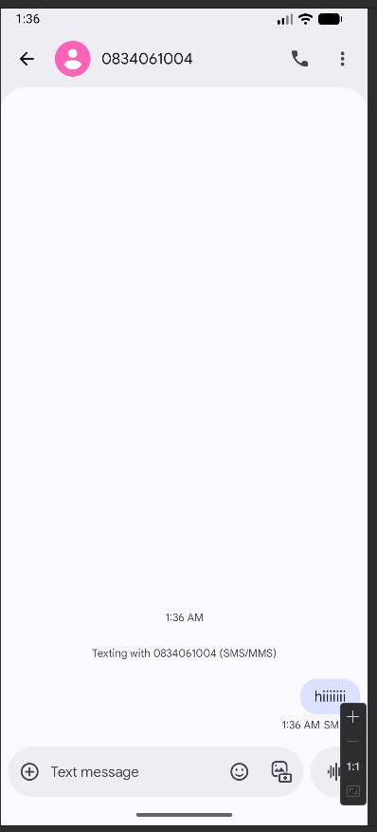 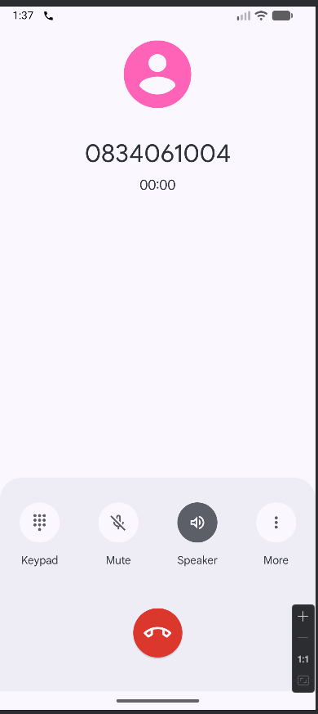

## BÀI 2

* 1. Tạo ứng dụng Animal sound

**Bai1Activity.java**

package com.example.btap8;  
  
import androidx.appcompat.app.AppCompatActivity;  
import android.content.Intent;  
import android.os.Bundle;  
import android.os.Handler;  
import android.view.View;  
import android.widget.ImageView;  
import android.widget.LinearLayout;  
import android.widget.TextView;  
import java.util.Random;  
  
public class Bai1Activity extends AppCompatActivity {  
  
 private View loadingView;  
 private LinearLayout contentLayout;  
 private ImageView imgAnimal;  
 private TextView txtTitle, btnBack;  
  
 private int[] colors = { 0xFFE57373, 0xFF64B5F6, 0xFF81C784, 0xFFFFD54F, 0xFFBA68C8 };  
 private int[] icons = { R.drawable.*ic_cat*, R.drawable.*ic_dog*, R.drawable.*ic_lion* };  
 private String[] names = { "Cat", "Dog", "Lion" };  
  
 @Override  
 protected void onCreate(Bundle savedInstanceState) {  
 super.onCreate(savedInstanceState);  
 setContentView(R.layout.*activity_bai1*);  
  
 // Ánh xạ View  
 loadingView = findViewById(R.id.*loadingView*);  
 contentLayout = findViewById(R.id.*contentLayout*);  
 imgAnimal = findViewById(R.id.*imgAnimal*);  
 txtTitle = findViewById(R.id.*txtTitle*);  
 btnBack = findViewById(R.id.*btnBack*);  
  
 // QUAY LẠI MENU  
 btnBack.setOnClickListener(v -> {  
 startActivity(new Intent(Bai1Activity.this, MainActivity.class));  
 finish();  
 });  
  
 // Loading 2 giây trước khi hiện Animal  
 new Handler().postDelayed(() -> {  
 loadingView.setVisibility(View.*GONE*);  
 contentLayout.setVisibility(View.*VISIBLE*);  
 randomSplash();  
 }, 2000);  
 }  
  
 private void randomSplash() {  
 Random random = new Random();  
 contentLayout.setBackgroundColor(colors[random.nextInt(colors.length)]);  
 int index = random.nextInt(icons.length);  
 imgAnimal.setImageResource(icons[index]);  
 txtTitle.setText("Animal Sound - " + names[index]);  
 }  
}

**activity_main.xml**

<?xml version="1.0" encoding="utf-8"?>  
<LinearLayout xmlns:android="http://schemas.android.com/apk/res/android"  
 android:layout_width="match_parent"  
 android:layout_height="match_parent"  
 android:gravity="center"  
 android:orientation="vertical"  
 android:padding="24dp"  
 android:background="#FAFAFA">  
  
 <Button  
 android:id="@+id/btnBai1"  
 android:layout_width="match_parent"  
 android:layout_height="wrap_content"  
 android:text="Bài 1: Random Animal"  
 android:layout_marginBottom="16dp" />  
  
 <Button  
 android:id="@+id/btnBai2"  
 android:layout_width="match_parent"  
 android:layout_height="wrap_content"  
 android:text="Bài 2: Loading Overlay" />  
</LinearLayout>

**activity_bai1.xml**

<?xml version="1.0" encoding="utf-8"?>  
<FrameLayout xmlns:android="http://schemas.android.com/apk/res/android"  
 android:layout_width="match_parent"  
 android:layout_height="match_parent">  
  
  
 <TextView  
 android:id="@+id/btnBack"  
 android:layout_width="match_parent"  
 android:layout_height="wrap_content"  
 android:gravity="center"  
 android:padding="16dp"  
 android:text="Quay lại"  
 android:textSize="18sp"  
 android:textStyle="bold" />  
  
 <!-- Giao diện Animal, đặt dưới nút quay lại -->  
 <LinearLayout  
 android:id="@+id/contentLayout"  
 android:layout_width="match_parent"  
 android:layout_height="match_parent"  
 android:gravity="center"  
 android:orientation="vertical"  
 android:paddingTop="60dp">  
  
 <ImageView  
 android:id="@+id/imgAnimal"  
 android:layout_width="200dp"  
 android:layout_height="200dp"  
 android:scaleType="centerCrop" />  
  
 <TextView  
 android:id="@+id/txtTitle"  
 android:layout_width="wrap_content"  
 android:layout_height="wrap_content"  
 android:layout_marginTop="20dp"  
 android:textSize="24sp"  
 android:textColor="#000000" />  
 </LinearLayout>  
  
   
 <include  
 android:id="@+id/loadingView"  
 layout="@layout/item_loading"  
 android:visibility="visible" />  
</FrameLayout>

* 1. Tạo giao diện loading

**ProfileActivity**

package com.example.btap8;  
  
import androidx.appcompat.app.AppCompatActivity;  
import android.os.Bundle;  
  
public class ProfileActivity extends AppCompatActivity {  
 @Override  
 protected void onCreate(Bundle savedInstanceState) {  
 super.onCreate(savedInstanceState);  
 setContentView(R.layout.*activity_profile*);  
 }  
}

**activity_profile.xml**

<?xml version="1.0" encoding="utf-8"?>  
<ScrollView xmlns:android="http://schemas.android.com/apk/res/android"  
 android:layout_width="match_parent"  
 android:layout_height="match_parent"  
 android:background="@color/gray_light">  
  
 <LinearLayout  
 android:layout_width="match_parent"  
 android:layout_height="wrap_content"  
 android:orientation="vertical"  
 android:padding="16dp"  
 android:gravity="center_horizontal">  
  
 <ImageView  
 android:id="@+id/img_avatar"  
 android:layout_width="160dp"  
 android:layout_height="160dp"  
 android:src="@drawable/avatar_me"  
 android:layout_marginTop="24dp"  
 android:layout_marginBottom="16dp"  
 android:scaleType="centerCrop"  
 android:background="@drawable/bg_oval"  
 android:clipToOutline="true" />  
  
 <TextView  
 android:id="@+id/tv_name"  
 android:layout_width="match_parent"  
 android:layout_height="wrap_content"  
 android:text="Văn Khánh"  
 android:textColor="@color/indigo"  
 android:textSize="24sp"  
 android:textStyle="bold"  
 android:layout_marginBottom="6dp" />  
  
 <TextView  
 android:text="Nhà bảo tồn động vật "  
 android:textColor="@color/gray_mid"  
 android:layout_width="match_parent"  
 android:layout_height="wrap_content"  
 android:textSize="16sp"  
 android:layout_marginBottom="12dp" />  
  
  
 <LinearLayout  
 android:layout_width="match_parent"  
 android:layout_height="wrap_content"  
 android:orientation="horizontal"  
 android:gravity="center"  
 android:layout_marginTop="24dp">  
  
 <ImageButton  
 android:layout_width="60dp"  
 android:layout_height="60dp"  
 android:src="@drawable/ic_back"  
 android:background="@drawable/bg_oval"  
 android:padding="14dp"  
 android:contentDescription="Quay lại" />  
  
  
 </LinearLayout>  
  
 </LinearLayout>  
</ScrollView>

* 1. Lập trình để khi bấm vào icon thì chuyển về cuộc gọi, sử dụng Intent.

**Bai2Activity.java**

package com.example.btap8;  
  
import androidx.appcompat.app.AppCompatActivity;  
import android.content.Intent;  
import android.net.Uri;  
import android.os.Bundle;  
import android.os.Handler;  
import android.view.View;  
import android.widget.Button;  
import android.widget.EditText;  
import android.widget.TextView;  
  
public class Bai2Activity extends AppCompatActivity {  
  
 private View loadingView;  
 private Button btnShowLoading, btnCall;  
 private EditText edtPhone;  
 private TextView btnBack;  
  
 @Override  
 protected void onCreate(Bundle savedInstanceState) {  
 super.onCreate(savedInstanceState);  
 setContentView(R.layout.*activity_bai2*);  
  
  
 loadingView = findViewById(R.id.*loadingView*);  
 btnShowLoading = findViewById(R.id.*btnShowLoading*);  
 btnCall = findViewById(R.id.*btnCall*);  
 edtPhone = findViewById(R.id.*edtPhone*);  
 btnBack = findViewById(R.id.*btnBack*);  
  
  
 btnBack.setOnClickListener(v -> {  
 startActivity(new Intent(Bai2Activity.this, MainActivity.class));  
 finish();  
 });  
  
  
 btnShowLoading.setOnClickListener(v -> {  
 loadingView.setVisibility(View.*VISIBLE*);  
 new Handler().postDelayed(() ->  
 loadingView.setVisibility(View.*GONE*), 2000);  
 });  
  
  
 btnCall.setOnClickListener(v -> {  
 String phone = edtPhone.getText().toString().trim();  
 if (!phone.isEmpty()) {  
 Intent intent = new Intent(Intent.*ACTION_DIAL*, Uri.*parse*("tel:" + phone));  
 startActivity(intent);  
 } else {  
 edtPhone.setError("Vui lòng nhập số điện thoại");  
 }  
 });  
 }  
}

**activity_bai2.xml**

<?xml version="1.0" encoding="utf-8"?>  
<FrameLayout xmlns:android="http://schemas.android.com/apk/res/android"  
 android:layout_width="match_parent"  
 android:layout_height="match_parent">  
  
 <!-- Nút QUAY LẠI ở trên đầu, căn giữa -->  
 <TextView  
 android:id="@+id/btnBack"  
 android:layout_width="match_parent"  
 android:layout_height="wrap_content"  
 android:gravity="center"  
 android:padding="16dp"  
 android:text="Quay lại"  
 android:textSize="18sp"  
 android:textStyle="bold" />  
  
   
 <LinearLayout  
 android:layout_width="match_parent"  
 android:layout_height="match_parent"  
 android:gravity="center"  
 android:orientation="vertical"  
 android:paddingTop="70dp">  
  
  
 <Button  
 android:id="@+id/btnShowLoading"  
 android:layout_width="wrap_content"  
 android:layout_height="wrap_content"  
 android:text="Show Loading"  
 android:layout_marginBottom="30dp" />  
  
   
 <EditText  
 android:id="@+id/edtPhone"  
 android:layout_width="match_parent"  
 android:layout_height="wrap_content"  
 android:hint="Nhập số điện thoại"  
 android:inputType="phone"  
 android:padding="12dp"  
 android:layout_marginBottom="16dp" />  
  
   
 <Button  
 android:id="@+id/btnCall"  
 android:layout_width="match_parent"  
 android:layout_height="wrap_content"  
 android:text="Gọi điện" />  
 </LinearLayout>  
  
   
 <include  
 android:id="@+id/loadingView"  
 layout="@layout/item_loading"  
 android:visibility="gone" />  
  
</FrameLayout>

# BUỔI THỰC HÀNH 2

## BÀI 3

* 1. Tạo chức năng On/Off xoay màn hình



* 1. Tạo ứng dụng đọc truyện bằng nhiều ngôn ngữ

1. package com.example.lap03.fragment;  
     
   import android.os.Bundle;  
   import android.os.Handler;  
   import android.os.Looper;  
   import android.view.LayoutInflater;  
   import android.view.View;  
   import android.view.ViewGroup;  
     
   import androidx.annotation.NonNull;  
   import androidx.annotation.Nullable;  
   import androidx.fragment.app.Fragment;  
     
   import com.example.lap03.R;  
     
   public class M000SplashFrg extends Fragment {  
     
    @Nullable  
    @Override  
    public View onCreateView(@NonNull LayoutInflater inflater,  
    @Nullable ViewGroup container,  
    @Nullable Bundle savedInstanceState) {  
    View view = inflater.inflate(R.layout.*m000_frg_splash*, container, false);  
     
    // ✅ Dùng Handler gắn với Looper chính để đảm bảo an toàn  
    new Handler(Looper.*getMainLooper*()).postDelayed(this::gotoNext, 2000);  
     
    return view;  
    }  
     
    private void gotoNext() {  
    if (getActivity() == null || !isAdded()) return; // 🔒 kiểm tra an toàn  
    try {  
    getActivity().getSupportFragmentManager()  
    .beginTransaction()  
    .replace(R.id.*fr_container*, new M001TopicFrg())  
    .addToBackStack(null)  
    .commitAllowingStateLoss(); // ✅ tránh crash khi activity đang recreate  
    } catch (Exception e) {  
    e.printStackTrace();  
    }  
    }  
   }
2. package com.example.lap03.fragment;  
     
   import android.os.Bundle;  
   import android.view.LayoutInflater;  
   import android.view.View;  
   import android.view.ViewGroup;  
   import android.widget.LinearLayout;  
     
   import androidx.annotation.NonNull;  
   import androidx.annotation.Nullable;  
   import androidx.fragment.app.Fragment;  
   import androidx.fragment.app.FragmentTransaction;  
     
   import com.example.lap03.R;  
     
   public class M001TopicFrg extends Fragment {  
     
    @Nullable  
    @Override  
    public View onCreateView(@NonNull LayoutInflater inflater,  
    @Nullable ViewGroup container,  
    @Nullable Bundle savedInstanceState) {  
    View view = inflater.inflate(R.layout.*m001_frg_topic*, container, false);  
     
    LinearLayout lnGirl = view.findViewById(R.id.*lnTopicGirl*);  
    LinearLayout lnBoy = view.findViewById(R.id.*lnTopicBoy*);  
     
    // Khi bấm vào chủ đề con gái  
    lnGirl.setOnClickListener(v -> openStoryFragment("girl"));  
     
    // Khi bấm vào chủ đề con trai  
    lnBoy.setOnClickListener(v -> openStoryFragment("boy"));  
     
    return view;  
    }  
     
    private void openStoryFragment(String topic) {  
    FragmentTransaction ft = getParentFragmentManager().beginTransaction();  
    Fragment storyFrg = new M002StoryFrg();  
     
    Bundle args = new Bundle();  
    args.putString("topic", topic);  
    storyFrg.setArguments(args);  
     
    ft.replace(R.id.*fr_container*, storyFrg);  
    ft.addToBackStack(null);  
    ft.commit();  
    }  
   }
3. package com.example.lap03.fragment;  
     
   import android.os.Bundle;  
   import android.view.LayoutInflater;  
   import android.view.View;  
   import android.view.ViewGroup;  
   import android.view.animation.Animation;  
   import android.view.animation.AnimationUtils;  
     
   import androidx.annotation.NonNull;  
   import androidx.annotation.Nullable;  
   import androidx.fragment.app.Fragment;  
     
   import com.example.lap03.R;  
     
   public class M002StoryFrg extends Fragment {  
     
    @Nullable  
    @Override  
    public View onCreateView(@NonNull LayoutInflater inflater,  
    @Nullable ViewGroup container,  
    @Nullable Bundle savedInstanceState) {  
    View view = inflater.inflate(R.layout.*m002_frg_story*, container, false);  
     
    // Lấy 2 item truyện  
    View lnStory1 = view.findViewById(R.id.*lnStory1*);  
    View lnStory2 = view.findViewById(R.id.*lnStory2*);  
     
    // Hiệu ứng click nhẹ  
    Animation clickAnim = AnimationUtils.*loadAnimation*(getContext(), R.anim.*item_click*);  
     
    // Gắn sự kiện click  
    lnStory1.setOnClickListener(v -> {  
    v.startAnimation(clickAnim);  
    openStoryDetail();  
    });  
     
    lnStory2.setOnClickListener(v -> {  
    v.startAnimation(clickAnim);  
    openStoryDetail();  
    });  
     
    return view;  
    }  
     
    private void openStoryDetail() {  
    requireActivity().getSupportFragmentManager()  
    .beginTransaction()  
    .replace(R.id.*fr_container*, new M003DetailFrg())  
    .addToBackStack(null)  
    .commit();  
    }  
   }
4. package com.example.lap03.fragment;  
     
   import android.os.Bundle;  
   import android.view.LayoutInflater;  
   import android.view.View;  
   import android.view.ViewGroup;  
   import android.widget.Button;  
   import android.widget.ImageView;  
   import android.widget.TextView;  
     
   import androidx.annotation.NonNull;  
   import androidx.annotation.Nullable;  
   import androidx.fragment.app.Fragment;  
     
   import com.example.lap03.R;  
     
   public class M003DetailFrg extends Fragment {  
     
    @Nullable  
    @Override  
    public View onCreateView(@NonNull LayoutInflater inflater,  
    @Nullable ViewGroup container,  
    @Nullable Bundle savedInstanceState) {  
    View view = inflater.inflate(R.layout.*m003_frg_detail*, container, false);  
     
    TextView tvTitle = view.findViewById(R.id.*tvStoryTitle*);  
    TextView tvContent = view.findViewById(R.id.*tvStoryContent*);  
    ImageView imgStory = view.findViewById(R.id.*imgStory*);  
    Button btnBack = view.findViewById(R.id.*btnBack*);  
     
    // Nhận dữ liệu từ Bundle  
    Bundle args = getArguments();  
    if (args != null) {  
    tvTitle.setText(args.getString("title"));  
    tvContent.setText(args.getString("content"));  
    int imgRes = args.getInt("imageRes", R.drawable.*img_rabbit*);  
    imgStory.setImageResource(imgRes);  
    }  
     
    btnBack.setOnClickListener(v -> requireActivity()  
    .getSupportFragmentManager()  
    .popBackStack());  
     
    return view;  
    }  
   }

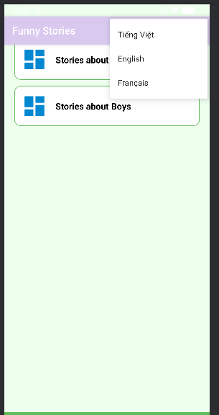

## BÀI 4

* 1. Tạo 1 ứng dụng Login

1. package com.example.lap04;  
     
   import android.content.Intent;  
   import android.os.Bundle;  
   import android.view.LayoutInflater;  
   import android.view.View;  
   import android.widget.EditText;  
   import android.widget.TextView;  
   import android.widget.Toast;  
     
   import androidx.appcompat.app.AppCompatActivity;  
     
   public class LoginActivity extends AppCompatActivity {  
    private EditText etEmail, etPassword;  
    private TextView btnLogin, btnToMenu;  
     
    @Override  
    protected void onCreate(Bundle savedInstanceState) {  
    super.onCreate(savedInstanceState);  
    setContentView(R.layout.*m001_act_login*);  
     
    etEmail = findViewById(R.id.*etEmail*);  
    etPassword = findViewById(R.id.*etPass*);  
    btnLogin = findViewById(R.id.*tvLogin*);  
    btnToMenu = findViewById(R.id.*tvToMenu*);  
     
    // Khi nhấn Login  
    btnLogin.setOnClickListener(v -> showCustomToast());  
     
    // Chuyển sang English Learning  
    btnToMenu.setOnClickListener(v -> {  
    Intent i = new Intent(LoginActivity.this, MainActivity.class);  
    startActivity(i);  
    });  
    }  
     
    private void showCustomToast() {  
    String email = etEmail.getText().toString().trim();  
    String pass = etPassword.getText().toString().trim();  
     
    View layout = LayoutInflater.*from*(this).inflate(R.layout.*toast_custom*, null);  
    TextView tvMsg = layout.findViewById(R.id.*tvMsg*);  
    tvMsg.setText("Bạn đã đăng nhập thành công với email: " + email + "\nMật khẩu: " + pass);  
     
    Toast toast = new Toast(this);  
    toast.setView(layout);  
    toast.setDuration(Toast.*LENGTH_LONG*);  
    toast.show();  
    }  
   }

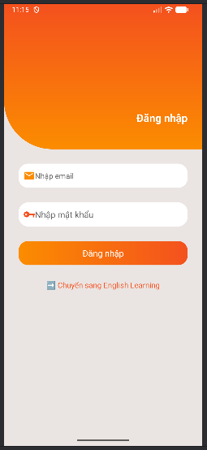

* 1. Tạo 1 ứng dụng English Learning

package com.example.lap04;  
  
import android.content.Intent;  
import android.os.Bundle;  
import android.view.LayoutInflater;  
import android.view.View;  
import android.widget.ImageView;  
import android.widget.LinearLayout;  
import android.widget.TextView;  
import android.widget.Toast;  
  
import androidx.appcompat.app.AppCompatActivity;  
  
public class MainActivity extends AppCompatActivity {  
 private static final int[] *ID_DRAWABLES* = {  
 R.drawable.*ic_mess*, R.drawable.*ic_flight*, R.drawable.*ic_hospital*,  
 R.drawable.*ic_hotel*, R.drawable.*ic_restaurant*, R.drawable.*ic_coctail*,  
 R.drawable.*ic_store*, R.drawable.*ic_work*, R.drawable.*ic_time*,  
 R.drawable.*ic_education*, R.drawable.*ic_movie* };  
  
 private static final int[] *ID_TEXTS* = {  
 R.string.*txt_mess*, R.string.*txt_flight*, R.string.*txt_hospital*,  
 R.string.*txt_hotel*, R.string.*txt_restaurant*, R.string.*txt_coctail*,  
 R.string.*txt_store*, R.string.*txt_work*, R.string.*txt_time*,  
 R.string.*txt_education*, R.string.*txt_movie* };  
  
 @Override  
 protected void onCreate(Bundle savedInstanceState) {  
 super.onCreate(savedInstanceState);  
 setContentView(R.layout.*activity_main*);  
 initView();  
 }  
  
 private void initView() {  
 LinearLayout lnMain = findViewById(R.id.*ln_main*);  
 lnMain.removeAllViews();  
  
 for (int i = 0; i < *ID_DRAWABLES*.length; i++) {  
 View v = LayoutInflater.*from*(this).inflate(R.layout.*item_topic*, null);  
 ImageView ivTopic = v.findViewById(R.id.*iv_topic*);  
 TextView tvTopic = v.findViewById(R.id.*tv_topic*);  
 ivTopic.setImageResource(*ID_DRAWABLES*[i]);  
 tvTopic.setText(*ID_TEXTS*[i]);  
  
 v.setOnClickListener(view ->  
 Toast.*makeText*(this, "Bạn chọn chủ đề: " + tvTopic.getText(), Toast.*LENGTH_SHORT*).show()  
 );  
 lnMain.addView(v);  
 }  
  
 // Nút chuyển sang FaceEmoji  
 TextView btnFace = findViewById(R.id.*tvToFaceEmoji*);  
 btnFace.setOnClickListener(v -> {  
 Intent intent = new Intent(MainActivity.this, FaceEmojiActivity.class);  
 startActivity(intent);  
 });  
  
 // Quay về Login  
 TextView btnBackLogin = findViewById(R.id.*tvBackLogin*);  
 btnBackLogin.setOnClickListener(v -> {  
 Intent intent = new Intent(MainActivity.this, LoginActivity.class);  
 startActivity(intent);  
 });  
 }  
}

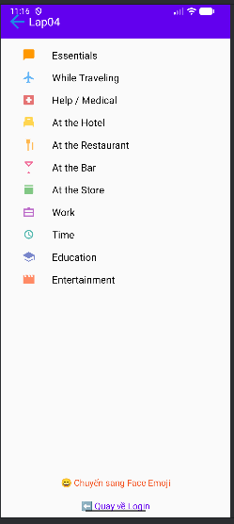

* 1. Tạo 1 ứng dụng Emoij

1. package com.example.lap04;  
     
   import android.content.Intent;  
   import android.os.Bundle;  
   import android.widget.Button;  
     
   import androidx.appcompat.app.AppCompatActivity;  
     
   public class FaceEmojiActivity extends AppCompatActivity {  
    @Override  
    protected void onCreate(Bundle savedInstanceState) {  
    super.onCreate(savedInstanceState);  
    setContentView(R.layout.*activity_face_emoji*);  
     
    Button btnBack = findViewById(R.id.*btnBackToMenu*);  
    Button btnRandom = findViewById(R.id.*btnRandom*);  
     
    // Quay về English Learning  
    btnBack.setOnClickListener(v -> {  
    Intent intent = new Intent(FaceEmojiActivity.this, MainActivity.class);  
    startActivity(intent);  
    });  
     
    // Random emoji trong fragment  
    btnRandom.setOnClickListener(v -> {  
    FragmentFaceEmoji fragment = (FragmentFaceEmoji)  
    getSupportFragmentManager().findFragmentById(R.id.*frg_face_emoij*);  
    if (fragment != null) {  
    fragment.randomEmojis();  
    }  
    });  
    }  
   }

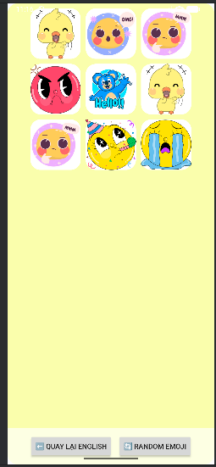

## BÀI 5

* 1. Tạo 1 ứng dụng Animation

package com.example.lab5;  
  
import android.os.Bundle;  
import android.view.View;  
import android.view.animation.Animation;  
import android.view.animation.AnimationUtils;  
import android.widget.ImageView;  
  
import androidx.appcompat.app.AppCompatActivity;  
  
import java.util.Random;  
  
public class AnimationActivity extends AppCompatActivity implements View.OnClickListener {  
  
 private ImageView ivAnimal;  
 private final int[] animList = {  
 R.anim.*alpha*,  
 R.anim.*scale*,  
 R.anim.*translate*,  
 R.anim.*rotate* };  
 private final Random random = new Random();  
  
 @Override  
 protected void onCreate(Bundle savedInstanceState) {  
 super.onCreate(savedInstanceState);  
 setContentView(R.layout.*activity_animation*);  
  
 ivAnimal = findViewById(R.id.*iv_animal*);  
  
 findViewById(R.id.*btn_alpha*).setOnClickListener(this);  
 findViewById(R.id.*btn_scale*).setOnClickListener(this);  
 findViewById(R.id.*btn_trans*).setOnClickListener(this);  
 findViewById(R.id.*btn_rotate*).setOnClickListener(this);  
 findViewById(R.id.*btn_random*).setOnClickListener(this);  
 }  
  
 @Override  
 public void onClick(View v) {  
 int id = v.getId();  
 Animation anim = null;  
  
 if (id == R.id.*btn_alpha*) {  
 anim = AnimationUtils.*loadAnimation*(this, R.anim.*alpha*);  
 } else if (id == R.id.*btn_scale*) {  
 anim = AnimationUtils.*loadAnimation*(this, R.anim.*scale*);  
 } else if (id == R.id.*btn_trans*) {  
 anim = AnimationUtils.*loadAnimation*(this, R.anim.*translate*);  
 } else if (id == R.id.*btn_rotate*) {  
 anim = AnimationUtils.*loadAnimation*(this, R.anim.*rotate*);  
 } else if (id == R.id.*btn_random*) {  
 int randomAnim = animList[random.nextInt(animList.length)];  
 anim = AnimationUtils.*loadAnimation*(this, randomAnim);  
 }  
  
 if (anim != null) {  
 ivAnimal.startAnimation(anim);  
 }  
 }  
}

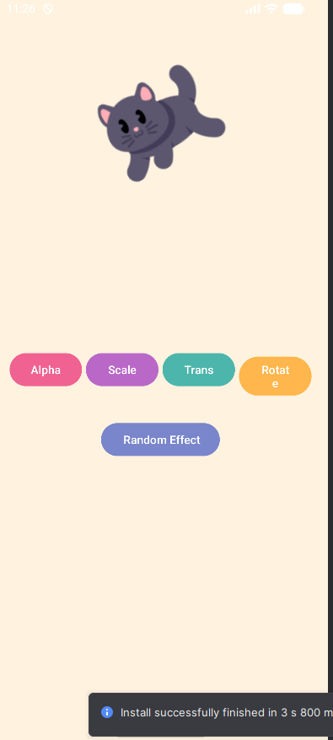

* 1. Tạo 1 ứng dụng Quick Call

package com.example.lab5;  
  
import android.Manifest;  
import android.content.Intent;  
import android.content.pm.PackageManager;  
import android.net.Uri;  
import android.os.Bundle;  
import android.view.View;  
import android.view.animation.AnimationUtils;  
import android.widget.FrameLayout;  
import android.widget.Toast;  
  
import androidx.appcompat.app.AppCompatActivity;  
  
public class QuickCallActivity extends AppCompatActivity implements View.OnClickListener {  
  
 @Override  
 protected void onCreate(Bundle savedInstanceState) {  
 super.onCreate(savedInstanceState);  
 setContentView(R.layout.*activity_quick_call*);  
 initView();  
 }  
  
 private void initView() {  
 findViewById(R.id.*fr_mom*).setOnClickListener(this);  
 findViewById(R.id.*fr_dad*).setOnClickListener(this);  
 findViewById(R.id.*fr_crush*).setOnClickListener(this);  
 findViewById(R.id.*fr_best_friend*).setOnClickListener(this);  
 findViewById(R.id.*iv_dialer*).setOnClickListener(this);  
 }  
  
 @Override  
 public void onClick(View v) {  
 v.startAnimation(AnimationUtils.*loadAnimation*(this,  
 androidx.appcompat.R.anim.*abc_popup_enter*));  
  
 if (v instanceof FrameLayout) {  
 processCall((String) v.getTag());  
 } else if (v.getId() == R.id.*iv_dialer*) {  
 gotoDialPad();  
 }  
 }  
  
 private void gotoDialPad() {  
 Intent intent = new Intent(Intent.*ACTION_DIAL*);  
 startActivity(intent);  
 }  
  
 private void processCall(String phone) {  
 if (checkSelfPermission(Manifest.permission.*CALL_PHONE*)  
 != PackageManager.*PERMISSION_GRANTED*) {  
 requestPermissions(new String[]{Manifest.permission.*CALL_PHONE*}, 101);  
 Toast.*makeText*(this, "Hãy cấp quyền rồi thử lại!", Toast.*LENGTH_SHORT*).show();  
 return;  
 }  
  
 Intent intent = new Intent(Intent.*ACTION_CALL*);  
 intent.setData(Uri.*parse*("tel:" + phone));  
 startActivity(intent);  
 }  
}

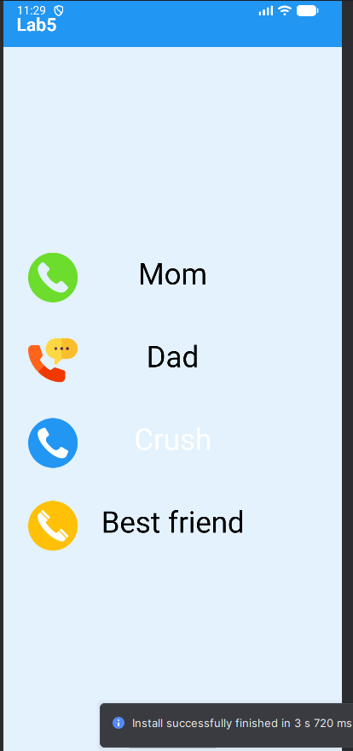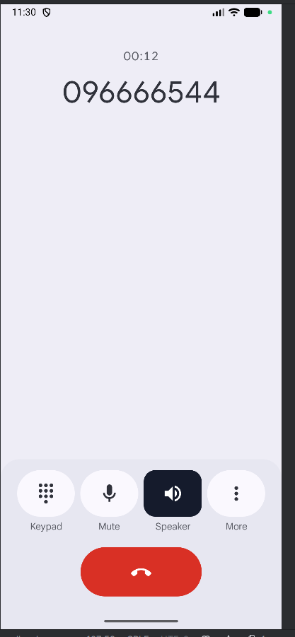

# BUỔI THỰC HÀNH 3

## BÀI 6

* 1. Tạo ứng dụng đổi tiền tệ

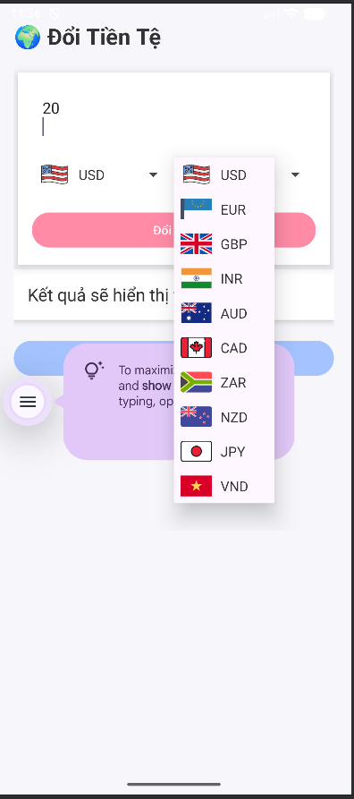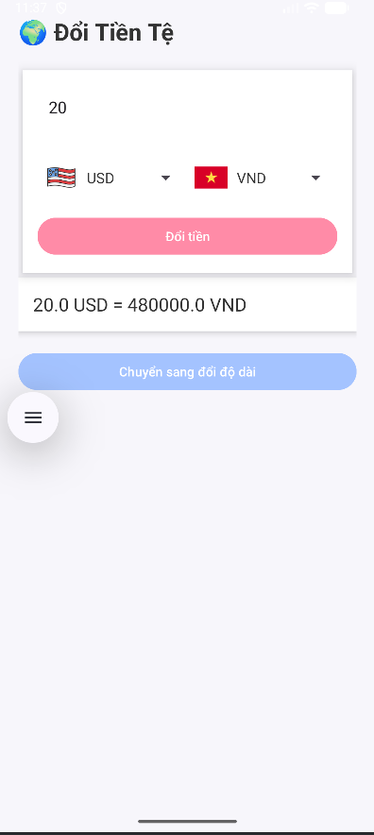

* 1. Tạo ứng dụng đổi đơn vị

1. package com.example.lap06;  
     
   import androidx.appcompat.app.AppCompatActivity;  
   import android.os.Bundle;  
   import android.widget.ArrayAdapter;  
   import android.widget.Button;  
   import android.widget.EditText;  
   import android.widget.Spinner;  
   import android.widget.TextView;  
     
   public class LengthActivity extends AppCompatActivity {  
     
    Spinner spnFromLength, spnToLength;  
    EditText edtValue;  
    Button btnConvertLength;  
    TextView txtLengthResult;  
     
    String[] lengthUnits = {"km", "hm", "dam", "m", "dm", "cm", "mm"};  
     
    double[] toMeter = {  
    1000, // km  
    100, // hm  
    10, // dam  
    1, // m  
    0.1, // dm  
    0.01, // cm  
    0.001 // mm  
    };  
     
    @Override  
    protected void onCreate(Bundle savedInstanceState) {  
    super.onCreate(savedInstanceState);  
    setContentView(R.layout.*activity_length*);  
     
    spnFromLength = findViewById(R.id.*spnFromLength*);  
    spnToLength = findViewById(R.id.*spnToLength*);  
    edtValue = findViewById(R.id.*edtValue*);  
    btnConvertLength = findViewById(R.id.*btnConvertLength*);  
    txtLengthResult = findViewById(R.id.*txtLengthResult*);  
     
    ArrayAdapter<String> adapter = new ArrayAdapter<>(  
    this, android.R.layout.*simple_spinner_item*, lengthUnits  
    );  
    adapter.setDropDownViewResource(android.R.layout.*simple_spinner_dropdown_item*);  
     
    spnFromLength.setAdapter(adapter);  
    spnToLength.setAdapter(adapter);  
     
    btnConvertLength.setOnClickListener(v -> {  
    String value = edtValue.getText().toString();  
    if (value.isEmpty()) {  
    txtLengthResult.setText("Vui lòng nhập số");  
    return;  
    }  
     
    double input = Double.*parseDouble*(value);  
    int from = spnFromLength.getSelectedItemPosition();  
    int to = spnToLength.getSelectedItemPosition();  
     
    double meterValue = input * toMeter[from];  
    double result = meterValue / toMeter[to];  
     
    txtLengthResult.setText(  
    input + " " + lengthUnits[from] + " = " +  
    result + " " + lengthUnits[to]  
    );  
    });  
    }  
   }



## BÀI 7

* 1. Sử dụng Custom Button

1. package com.example.lap07;  
     
   import android.os.Bundle;  
   import androidx.appcompat.app.AppCompatActivity;  
     
   public class B1_CustomButtonActivity extends AppCompatActivity {  
     
    @Override  
    protected void onCreate(Bundle savedInstanceState) {  
    super.onCreate(savedInstanceState);  
    setContentView(R.layout.*activity_b1*); // giao diện bài 1  
    }  
   }

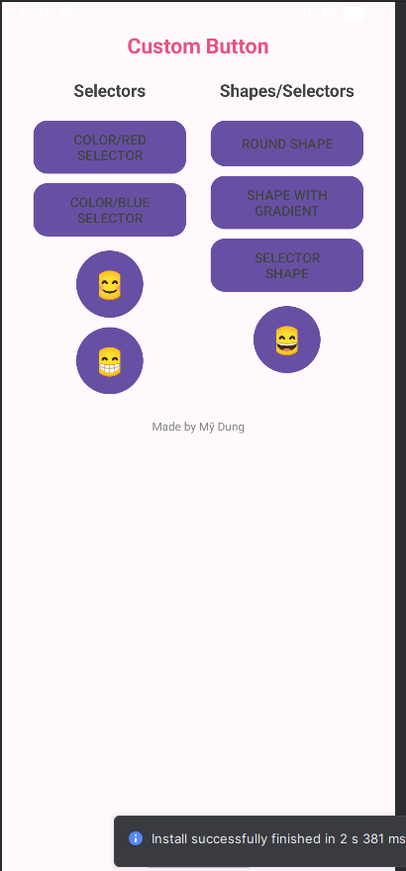

* 1. Kết hợp thêm Custom Toast và Custom Dialog

1. package com.example.lap07;  
     
   import android.app.Dialog;  
   import android.os.Bundle;  
   import android.view.LayoutInflater;  
   import android.view.View;  
   import android.widget.Button;  
   import android.widget.Toast;  
     
   import androidx.appcompat.app.AppCompatActivity;  
     
   public class B2_CustomDialogToastActivity extends AppCompatActivity {  
     
    Button btnShowToast, btnShowDialog;  
     
    @Override  
    protected void onCreate(Bundle savedInstanceState) {  
    super.onCreate(savedInstanceState);  
    setContentView(R.layout.*activity_b2*); // giao diện bài 2  
     
    btnShowToast = findViewById(R.id.*btnShowToast*);  
    btnShowDialog = findViewById(R.id.*btnShowDialog*);  
     
    // CUSTOM TOAST  
    btnShowToast.setOnClickListener(v -> {  
    LayoutInflater inflater = getLayoutInflater();  
    View layout = inflater.inflate(R.layout.*custom_toast*, null);  
     
    Toast toast = new Toast(getApplicationContext());  
    toast.setDuration(Toast.*LENGTH_SHORT*);  
    toast.setView(layout);  
    toast.show();  
    });  
     
    // CUSTOM DIALOG  
    btnShowDialog.setOnClickListener(v -> {  
    Dialog dialog = new Dialog(B2_CustomDialogToastActivity.this);  
    dialog.setContentView(R.layout.*custom_dialog*);  
     
    Button ok = dialog.findViewById(R.id.*btnOK*);  
    Button cancel = dialog.findViewById(R.id.*btnCancel*);  
     
    ok.setOnClickListener(v1 -> {  
    Toast.*makeText*(this, "Bạn đã đồng ý", Toast.*LENGTH_SHORT*).show();  
    dialog.dismiss();  
    });  
     
    cancel.setOnClickListener(v12 -> dialog.dismiss());  
     
    dialog.show();  
    });  
    }  
   }

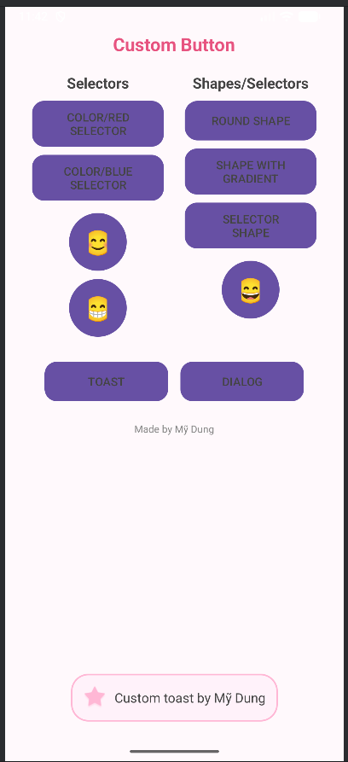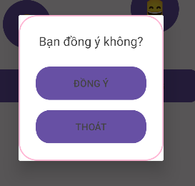

* 1. Viết chương trình cho phép chọn màu RGB và màu CMY

1. package com.example.lap07;  
     
   import android.graphics.Color;  
   import android.os.Bundle;  
   import android.widget.SeekBar;  
   import android.widget.TextView;  
   import android.view.View;  
     
   import androidx.appcompat.app.AppCompatActivity;  
     
   public class B3_SeekbarActivity extends AppCompatActivity {  
     
    SeekBar skR, skG, skB;  
    TextView tvR, tvG, tvB;  
    View viewRGB, viewCMY;  
     
    int r = 0, g = 0, b = 0;  
     
    @Override  
    protected void onCreate(Bundle savedInstanceState) {  
    super.onCreate(savedInstanceState);  
    setContentView(R.layout.*activity_b3*);  
     
    skR = findViewById(R.id.*skR*);  
    skG = findViewById(R.id.*skG*);  
    skB = findViewById(R.id.*skB*);  
     
    tvR = findViewById(R.id.*tvR*);  
    tvG = findViewById(R.id.*tvG*);  
    tvB = findViewById(R.id.*tvB*);  
     
    viewRGB = findViewById(R.id.*viewRGB*);  
    viewCMY = findViewById(R.id.*viewCMY*);  
     
    SeekBar.OnSeekBarChangeListener listener = new SeekBar.OnSeekBarChangeListener() {  
    @Override  
    public void onProgressChanged(SeekBar seekBar, int value, boolean fromUser) {  
     
    r = skR.getProgress();  
    g = skG.getProgress();  
    b = skB.getProgress();  
     
    // cập nhật text  
    tvR.setText("R = " + r);  
    tvG.setText("G = " + g);  
    tvB.setText("B = " + b);  
     
    // RGB block  
    viewRGB.setBackgroundColor(Color.*rgb*(r, g, b));  
     
    // CMY block  
    int c = 255 - r;  
    int m = 255 - g;  
    int y = 255 - b;  
     
    viewCMY.setBackgroundColor(Color.*rgb*(c, m, y));  
    }  
     
    @Override  
    public void onStartTrackingTouch(SeekBar seekBar) {}  
     
    @Override  
    public void onStopTrackingTouch(SeekBar seekBar) {}  
    };  
     
    skR.setOnSeekBarChangeListener(listener);  
    skG.setOnSeekBarChangeListener(listener);  
    skB.setOnSeekBarChangeListener(listener);  
    }  
   }

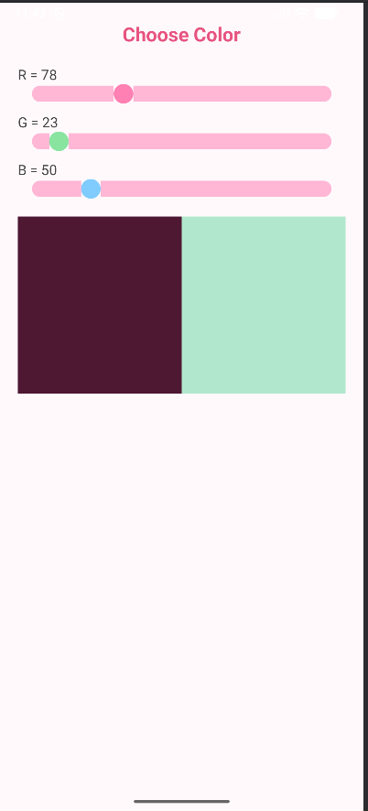

## BÀI 8

* 1. Xây dựng chương trình hiển thị và quản lý các món ǎn

1. package com.example.lap08;  
     
   import androidx.appcompat.app.AlertDialog;  
   import androidx.appcompat.app.AppCompatActivity;  
     
   import android.os.Bundle;  
   import android.view.View;  
   import android.widget.*;  
     
   import java.util.ArrayList;  
     
   public class Bai1Activity extends AppCompatActivity {  
     
    ListView listFood;  
    ImageButton btnAdd; // NÚT FLOATING BUTTON  
    ArrayList<Food> data;  
    FoodAdapter adapter;  
     
    int[] imageList = {  
    R.drawable.*hamburger*,  
    R.drawable.*banhmi*,  
    R.drawable.*pho*,  
    R.drawable.*comtam*,  
    R.drawable.*banh_chuoi*,  
    R.drawable.*milk_tea* };  
     
    String[] imageNames = {  
    "Hamburger",  
    "Bánh mì",  
    "Phở",  
    "Cơm tấm",  
    "Bánh chuối",  
    "Trà sữa"  
    };  
     
    @Override  
    protected void onCreate(Bundle savedInstanceState) {  
    super.onCreate(savedInstanceState);  
    setContentView(R.layout.*activity_bai1*);  
     
    // ẨN ACTION BAR  
    try { getSupportActionBar().hide(); } catch (Exception ignored) {}  
     
    listFood = findViewById(R.id.*listFood*);  
    btnAdd = findViewById(R.id.*btnAdd*);  
     
    // Danh sách món ăn mặc định  
    data = new ArrayList<>();  
    data.add(new Food(R.drawable.*hamburger*, "Hamburger", "Bánh mì kẹp thịt", "40.000đ"));  
    data.add(new Food(R.drawable.*banhmi*, "Bánh mì", "Bánh mì thịt nguội", "12.000đ"));  
    data.add(new Food(R.drawable.*pho*, "Phở bò", "Phở tái nạm", "45.000đ"));  
    data.add(new Food(R.drawable.*comtam*, "Cơm tấm", "Sườn - Bì - Chả", "35.000đ"));  
     
    // Adapter  
    adapter = new FoodAdapter(this, data, new FoodAdapter.OnFoodAction() {  
    @Override  
    public void edit(int pos) {  
    showDialogEdit(pos);  
    }  
     
    @Override  
    public void delete(int pos) {  
    data.remove(pos);  
    adapter.notifyDataSetChanged();  
    }  
    });  
     
    listFood.setAdapter(adapter);  
     
    // NÚT + (THÊM MÓN)  
    btnAdd.setOnClickListener(v -> showDialogAdd());  
    }  
     
    // THÊM MÓN  
    private void showDialogAdd() {  
     
    View v = getLayoutInflater().inflate(R.layout.*dialog_food*, null);  
     
    EditText edtName = v.findViewById(R.id.*edtName*);  
    EditText edtDesc = v.findViewById(R.id.*edtDesc*);  
    EditText edtPrice = v.findViewById(R.id.*edtPrice*);  
    Spinner spImage = v.findViewById(R.id.*spImage*);  
     
    ArrayAdapter<String> spAdapter =  
    new ArrayAdapter<>(this, android.R.layout.*simple_spinner_dropdown_item*, imageNames);  
    spImage.setAdapter(spAdapter);  
     
    new AlertDialog.Builder(this)  
    .setTitle("Thêm món ăn")  
    .setView(v)  
    .setPositiveButton("Thêm", (d, w) -> {  
     
    int index = spImage.getSelectedItemPosition();  
     
    data.add(new Food(  
    imageList[index],  
    edtName.getText().toString(),  
    edtDesc.getText().toString(),  
    edtPrice.getText().toString()  
    ));  
     
    adapter.notifyDataSetChanged();  
    })  
    .setNegativeButton("Hủy", null)  
    .show();  
    }  
     
    // SỬA MÓN  
    private void showDialogEdit(int pos) {  
     
    Food f = data.get(pos);  
     
    View v = getLayoutInflater().inflate(R.layout.*dialog_food*, null);  
     
    EditText edtName = v.findViewById(R.id.*edtName*);  
    EditText edtDesc = v.findViewById(R.id.*edtDesc*);  
    EditText edtPrice = v.findViewById(R.id.*edtPrice*);  
    Spinner spImage = v.findViewById(R.id.*spImage*);  
     
    edtName.setText(f.getName());  
    edtDesc.setText(f.getDesc());  
    edtPrice.setText(f.getPrice());  
     
    ArrayAdapter<String> spAdapter =  
    new ArrayAdapter<>(this, android.R.layout.*simple_spinner_dropdown_item*, imageNames);  
    spImage.setAdapter(spAdapter);  
     
    int index = 0;  
    for (int i = 0; i < imageList.length; i++) {  
    if (imageList[i] == f.getImageRes()) {  
    index = i;  
    break;  
    }  
    }  
    spImage.setSelection(index);  
     
    new AlertDialog.Builder(this)  
    .setTitle("Sửa món")  
    .setView(v)  
    .setPositiveButton("Lưu", (d, w) -> {  
     
    int imgIndex = spImage.getSelectedItemPosition();  
     
    f.setImageRes(imageList[imgIndex]);  
    f.setName(edtName.getText().toString());  
    f.setDesc(edtDesc.getText().toString());  
    f.setPrice(edtPrice.getText().toString());  
     
    adapter.notifyDataSetChanged();  
    })  
    .setNegativeButton("Hủy", null)  
    .show();  
    }  
   }
2. package com.example.lap08;  
     
   import androidx.appcompat.app.AppCompatActivity;  
   import android.os.Bundle;  
   import android.widget.GridView;  
     
   import java.util.ArrayList;  
     
   public class Bai2Activity extends AppCompatActivity {  
     
    GridView gridView;  
    ArrayList<Food> data;  
    FoodGridAdapter adapter;  
     
    @Override  
    protected void onCreate(Bundle savedInstanceState) {  
    super.onCreate(savedInstanceState);  
    setContentView(R.layout.*activity_bai2*);  
     
    gridView = findViewById(R.id.*gridView*);  
     
    data = new ArrayList<>();  
     
    data.add(new Food(R.drawable.*hamburger*, "Hamburger", "Bánh mì kẹp thịt", "40.000đ"));  
    data.add(new Food(R.drawable.*banhmi*, "Bánh mì", "Bánh mì thịt nguội", "12.000đ"));  
    data.add(new Food(R.drawable.*pho*, "Phở bò", "Phở tái nạm", "45.000đ"));  
    data.add(new Food(R.drawable.*comtam*, "Cơm tấm", "Sườn - Bì - Chả", "35.000đ"));  
    data.add(new Food(R.drawable.*banh_chuoi*, "Bánh chuối chiên", "Giòn – thơm", "10.000đ"));  
    data.add(new Food(R.drawable.*milk_tea*, "Trà sữa", "Trân châu đường đen", "25.000đ"));  
     
    adapter = new FoodGridAdapter(this, data);  
    gridView.setAdapter(adapter);  
    }  
   }

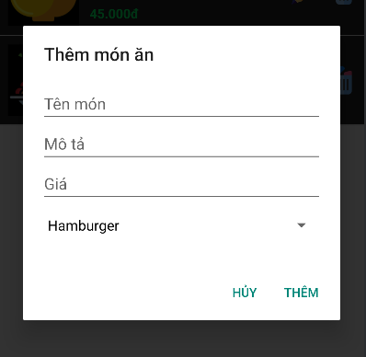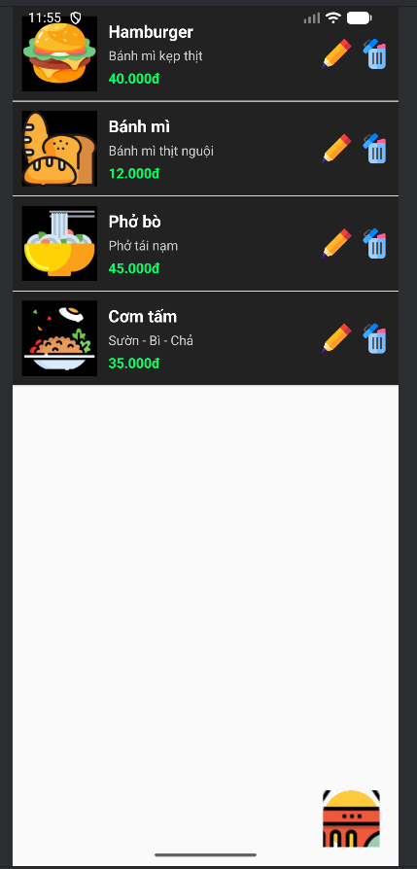 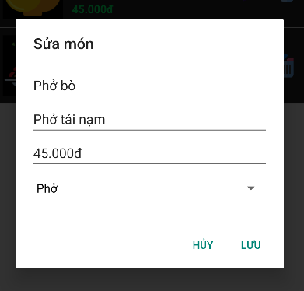

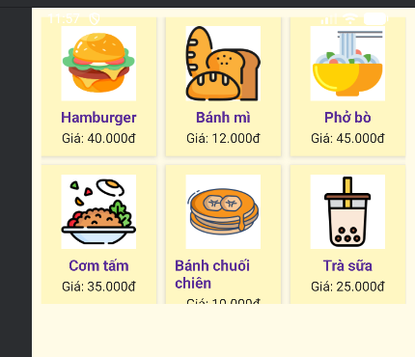

# BUỔI THỰC HÀNH 4

## BÀI 9

* 1. Tạo ứng dụng biểu đồ

1. package com.example.buoi14.lab9.bai1;  
     
   import androidx.appcompat.app.AppCompatActivity;  
   import android.os.Bundle;  
   import android.widget.FrameLayout;  
     
   import com.example.buoi14.R;  
     
   public class ChartActivity extends AppCompatActivity {  
     
    @Override  
    protected void onCreate(Bundle savedInstanceState) {  
    super.onCreate(savedInstanceState);  
    setContentView(R.layout.*activity_chart*);  
     
    FrameLayout container = findViewById(R.id.*chartContainer*);  
     
    int mode = getIntent().getIntExtra("CHART_MODE", 0);  
    int[] data = getIntent().getIntArrayExtra("CHART_DATA");  
     
    ChartView view = new ChartView(this, mode, data);  
    container.addView(view);  
    }  
   }
2. package com.example.buoi14.lab9.bai1;  
     
   import android.content.Context;  
   import android.graphics.Canvas;  
   import android.graphics.Color;  
   import android.graphics.Paint;  
   import android.view.View;  
     
   public class ChartView extends View {  
     
    private int chartMode; // 0 = Bar, 1 = Power, 2 = Pie  
    private int[] data;  
    private Paint p;  
     
    public ChartView(Context context, int mode, int[] data) {  
    super(context);  
    this.chartMode = mode;  
    this.data = data;  
    p = new Paint(Paint.*ANTI_ALIAS_FLAG*);  
    p.setTextSize(48);  
    p.setStrokeWidth(6);  
    }  
     
    @Override  
    protected void onDraw(Canvas canvas) {  
    super.onDraw(canvas);  
     
    canvas.drawColor(Color.*WHITE*);  
     
    switch (chartMode) {  
    case 0:  
    drawBarChart(canvas);  
    break;  
    case 1:  
    drawPowerChart(canvas);  
    break;  
    case 2:  
    drawPieChart(canvas);  
    break;  
    }  
    }  
     
    // ------------------------------  
    // 1) BAR CHART  
    // ------------------------------  
    private void drawBarChart(Canvas c) {  
    int w = getWidth();  
    int h = getHeight();  
     
    int barWidth = w / (data.length * 2);  
     
    int max = 0;  
    for (int v : data) if (v > max) max = v;  
     
    int x = barWidth;  
     
    for (int v : data) {  
    float barHeight = (float) v / max * (h * 0.7f);  
     
    p.setColor(Color.*rgb*(70, 130, 180));  
    c.drawRect(x, h - barHeight, x + barWidth, h, p);  
     
    p.setColor(Color.*BLACK*);  
    c.drawText(String.*valueOf*(v), x, h - barHeight - 20, p);  
     
    x += barWidth * 2;  
    }  
    }  
     
    // ------------------------------  
    // 2) POWER CHART giống hình 250W  
    // ------------------------------  
    private void drawPowerChart(Canvas c) {  
    int w = getWidth();  
    int h = getHeight();  
     
    // Text "POWER NOW: 250W"  
    p.setColor(Color.*BLUE*);  
    p.setTextSize(90);  
    c.drawText(data[0] + "W", 50, 120, p);  
     
    // Sub text  
    p.setTextSize(40);  
    c.drawText("USE TODAY: " + data[1] + " kWh", 50, 180, p);  
     
    // Draw bars  
    p.setTextSize(30);  
    int barWidth = 60;  
    int spacing = 30;  
     
    int max = 0;  
    for (int v : data) if (v > max) max = v;  
     
    int x = 50;  
     
    for (int i = 0; i < data.length; i++) {  
    int v = data[i];  
    float barHeight = (float) v / max * (h * 0.6f);  
     
    p.setColor(Color.*CYAN*);  
    c.drawRect(x, h - barHeight - 50, x + barWidth, h - 50, p);  
     
    p.setColor(Color.*WHITE*);  
    c.drawText(String.*valueOf*(v), x + 10, h - barHeight - 70, p);  
     
    x += barWidth + spacing;  
    }  
    }  
     
    // ------------------------------  
    // 3) PIE CHART  
    // ------------------------------  
    private void drawPieChart(Canvas c) {  
    int w = getWidth();  
    int h = getHeight();  
    int radius = Math.*min*(w, h) / 3;  
     
    int cx = w / 2;  
    int cy = h / 2;  
     
    int total = 0;  
    for (int v : data) total += v;  
     
    float startAngle = 0;  
     
    int[] colors = {  
    Color.*RED*, Color.*BLUE*, Color.*YELLOW*, Color.*GREEN*, Color.*MAGENTA* };  
     
    for (int i = 0; i < data.length; i++) {  
    float sweep = 360f * data[i] / total;  
     
    p.setColor(colors[i % colors.length]);  
    c.drawArc(cx - radius, cy - radius, cx + radius, cy + radius,  
    startAngle, sweep, true, p);  
     
    startAngle += sweep;  
    }  
    }  
   }

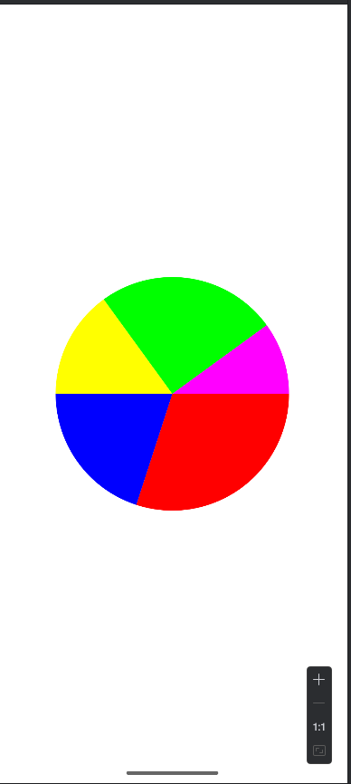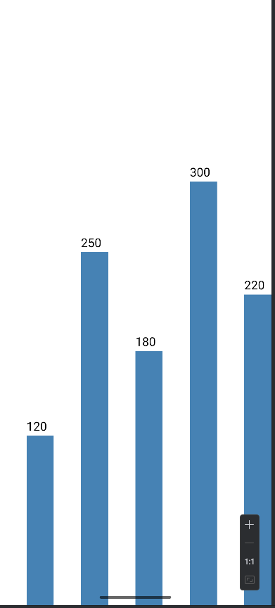 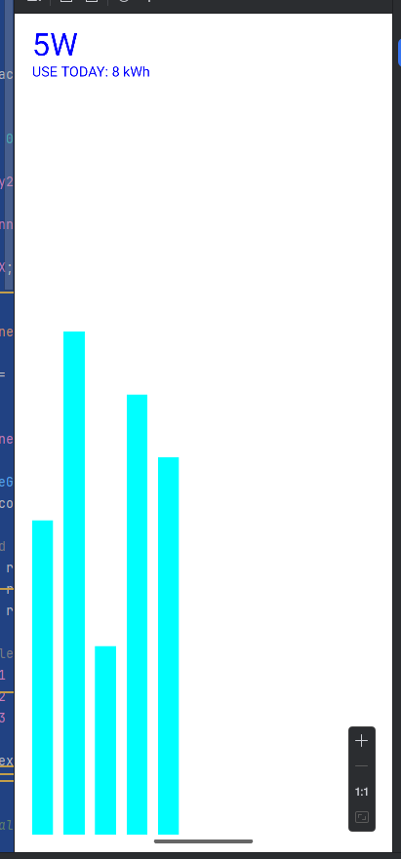

* 1. Tạo ứng dụng cuộc đua kì thú

package com.example.buoi14.lab9.bai2;  
  
import androidx.appcompat.app.AppCompatActivity;  
import android.os.Bundle;  
import android.widget.Button;  
import android.widget.FrameLayout;  
  
import com.example.buoi14.R;  
  
public class RaceGameActivity extends AppCompatActivity {  
  
 RaceGameView gameView;  
 Button btnStart, btnReset;  
  
 @Override  
 protected void onCreate(Bundle savedInstanceState) {  
 super.onCreate(savedInstanceState);  
 setContentView(R.layout.*activity_race_game*);  
  
 btnStart = findViewById(R.id.*btnStart*);  
 btnReset = findViewById(R.id.*btnReset*);  
  
 FrameLayout container = findViewById(R.id.*gameContainer*);  
  
 gameView = new RaceGameView(this);  
 container.addView(gameView);  
  
 btnStart.setOnClickListener(v -> gameView.startRace());  
 btnReset.setOnClickListener(v -> gameView.resetRace());  
 }  
}

package com.example.buoi14.lab9.bai2;  
  
import android.content.Context;  
import android.graphics.*;  
import android.view.View;  
import android.widget.Toast;  
  
import com.example.buoi14.R;  
  
import java.util.Random;  
  
public class RaceGameView extends View {  
  
 float x1 = 0, x2 = 0, x3 = 0;  
 float y1, y2, y3;  
 boolean running = false;  
 int finishX;  
  
 Paint p = new Paint();  
 Random rd = new Random();  
  
 Bitmap runner1, runner2, runner3;  
  
 public RaceGameView(Context context) {  
 super(context);  
  
 // Load ảnh gốc  
 Bitmap r1 = BitmapFactory.*decodeResource*(getResources(), R.drawable.*runner1*);  
 Bitmap r2 = BitmapFactory.*decodeResource*(getResources(), R.drawable.*runner2*);  
 Bitmap r3 = BitmapFactory.*decodeResource*(getResources(), R.drawable.*runner3*);  
  
 // Scale ảnh xuống nhỏ lại (80px chiều rộng)  
 runner1 = scaleBitmap(r1, 80);  
 runner2 = scaleBitmap(r2, 80);  
 runner3 = scaleBitmap(r3, 80);  
  
 p.setTextSize(50);  
 }  
  
 */** Hàm scale ảnh theo chiều rộng mong muốn */* private Bitmap scaleBitmap(Bitmap bm, int newWidth) {  
 float ratio = (float)newWidth / bm.getWidth();  
 int newHeight = (int)(bm.getHeight() * ratio);  
 return Bitmap.*createScaledBitmap*(bm, newWidth, newHeight, true);  
 }  
  
 @Override  
 protected void onSizeChanged(int w, int h, int oldw, int oldh) {  
 y1 = h * 0.30f;  
 y2 = h * 0.50f;  
 y3 = h * 0.70f;  
 finishX = w - 200;  
 super.onSizeChanged(w, h, oldw, oldh);  
 }  
  
 public void startRace() {  
 if (running) return;  
 running = true;  
  
 Thread t = new Thread(() -> {  
 while (running) {  
  
 x1 += rd.nextInt(10) + 5;  
 x2 += rd.nextInt(10) + 5;  
 x3 += rd.nextInt(10) + 5;  
  
 if (x1 >= finishX) {  
 running = false;  
 post(() -> Toast.*makeText*(getContext(), "Người 1 thắng!", Toast.*LENGTH_SHORT*).show());  
 } else if (x2 >= finishX) {  
 running = false;  
 post(() -> Toast.*makeText*(getContext(), "Người 2 thắng!", Toast.*LENGTH_SHORT*).show());  
 } else if (x3 >= finishX) {  
 running = false;  
 post(() -> Toast.*makeText*(getContext(), "Người 3 thắng!", Toast.*LENGTH_SHORT*).show());  
 }  
  
 postInvalidate();  
  
 try { Thread.*sleep*(60); } catch (Exception ignored) {}  
 }  
 });  
 t.start();  
 }  
  
 public void resetRace() {  
 running = false;  
 x1 = x2 = x3 = 0;  
 invalidate();  
 }  
  
 @Override  
 protected void onDraw(Canvas c) {  
 super.onDraw(c);  
  
 c.drawColor(Color.*WHITE*);  
  
 // Vẽ vạch đích  
 p.setColor(Color.*RED*);  
 c.drawLine(finishX, 0, finishX, getHeight(), p);  
  
 // Vẽ nhân vật  
 c.drawBitmap(runner1, x1, y1 - runner1.getHeight()/2, null);  
 c.drawBitmap(runner2, x2, y2 - runner2.getHeight()/2, null);  
 c.drawBitmap(runner3, x3, y3 - runner3.getHeight()/2, null);  
 }  
}

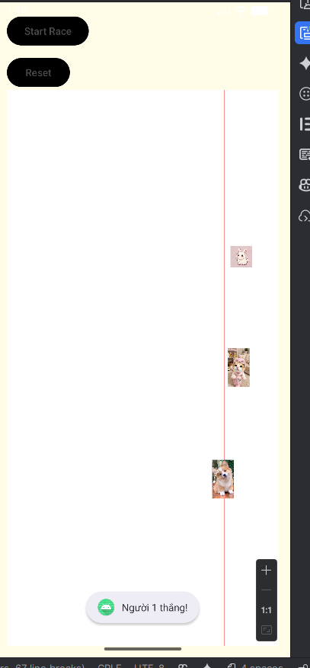

## BÀI 10+11

* 1. Tạo ứng dụng truyện cổ tích

package com.example.buoi14.truyencotich;  
  
import android.os.Bundle;  
import androidx.appcompat.app.AppCompatActivity;  
import androidx.appcompat.widget.Toolbar;  
import androidx.recyclerview.widget.LinearLayoutManager;  
import androidx.recyclerview.widget.RecyclerView;  
  
import com.example.buoi14.R;  
import com.example.buoi14.truyencotich.adapter.StoryAdapter;  
import com.example.buoi14.truyencotich.data.StoryData; // Corrected import  
import com.example.buoi14.truyencotich.models.Story;  
  
import java.util.ArrayList; // Use ArrayList to match adapter  
  
public class CategoryActivity extends AppCompatActivity {  
  
 private RecyclerView rvStories;  
 private StoryAdapter storyAdapter;  
 private ArrayList<Story> storyList;  
  
 @Override  
 protected void onCreate(Bundle savedInstanceState) {  
 super.onCreate(savedInstanceState);  
 setContentView(R.layout.*activity_category*);  
  
 // Setup Toolbar  
 Toolbar toolbar = findViewById(R.id.*toolbar*);  
 setSupportActionBar(toolbar);  
 getSupportActionBar().setDisplayHomeAsUpEnabled(true);  
 getSupportActionBar().setDisplayShowHomeEnabled(true);  
  
 // Initialize RecyclerView  
 rvStories = findViewById(R.id.*rvStories*);  
 rvStories.setLayoutManager(new LinearLayoutManager(this));  
  
 // Load data and setup adapter  
 storyList = StoryData.*getStories*(); // Corrected method call  
 storyAdapter = new StoryAdapter(this, storyList);  
 rvStories.setAdapter(storyAdapter);  
 }  
  
 @Override  
 public boolean onSupportNavigateUp() {  
 onBackPressed();  
 return true;  
 }  
}

package com.example.buoi14.truyencotich;  
  
import androidx.appcompat.app.AppCompatActivity;  
import android.os.Bundle;  
import android.widget.Button;  
import android.widget.ImageView;  
import android.widget.TextView;  
  
import com.example.buoi14.R;  
  
import java.io.IOException;  
import java.io.InputStream;  
  
public class StoryDetailActivity extends AppCompatActivity {  
  
 private ImageView imgPaper;  
 private TextView tvCaption, tvContent;  
 private Button btnBack;  
  
 @Override  
 protected void onCreate(Bundle savedInstanceState) {  
 super.onCreate(savedInstanceState);  
 setContentView(R.layout.*m002_story_detail*);  
  
 imgPaper = findViewById(R.id.*imgPaper*);  
 tvCaption = findViewById(R.id.*tvCaption*);  
 tvContent = findViewById(R.id.*tvContent*);  
 btnBack = findViewById(R.id.*btnBack*);  
  
 loadData();  
  
 btnBack.setOnClickListener(v -> finish());  
 }  
  
 private void loadData() {  
 String title = getIntent().getStringExtra("title");  
 String fileName = getIntent().getStringExtra("file");  
 int image = getIntent().getIntExtra("image", 0);  
  
 if (title != null) tvCaption.setText(title);  
 if (image != 0) imgPaper.setImageResource(image);  
  
 if (fileName != null) {  
 tvContent.setText(readFromAssets(fileName));  
 } else {  
 tvContent.setText("Không thể tải nội dung truyện.");  
 }  
 }  
  
 private String readFromAssets(String fileName) {  
 try {  
 // FIX QUAN TRỌNG ❗❗❗  
 InputStream is = getAssets().open("story/" + fileName);  
  
 int size = is.available();  
 byte[] buffer = new byte[size];  
 is.read(buffer);  
 is.close();  
  
 return new String(buffer, "UTF-8");  
  
 } catch (IOException e) {  
 e.printStackTrace();  
 return "Không thể tải nội dung truyện.";  
 }  
 }  
}

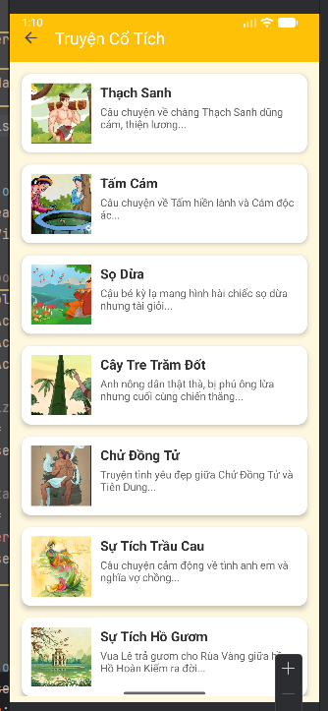 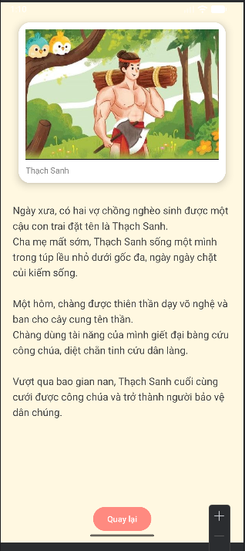

* 1. Tạo úng dụng truyện cung hoàng đạo

package com.example.buoi14.hoangdao;  
  
import androidx.appcompat.app.AppCompatActivity;  
import android.content.Intent;  
import android.os.Bundle;  
import android.view.View;  
import android.widget.ImageView;  
import android.widget.Button;  
import android.widget.TextView;  
  
import com.example.buoi14.R;  
import com.example.buoi14.hoangdao.model.Zodiac;  
import com.example.buoi14.hoangdao.utils.ZodiacData;  
  
public class M001MenuActivity extends AppCompatActivity {  
  
 private ImageView imgSelected;  
 private TextView tvName, tvShortDesc;  
 private Button btnXemThem;  
  
 private Zodiac selectedZodiac = null;  
 private Zodiac[] data = ZodiacData.*getAll*();  
  
 @Override  
 protected void onCreate(Bundle savedInstanceState) {  
 super.onCreate(savedInstanceState);  
 setContentView(R.layout.*m001_frg_menu*);  
  
 imgSelected = findViewById(R.id.*imgSelected*);  
 tvName = findViewById(R.id.*tvName*);  
 tvShortDesc = findViewById(R.id.*tvShortDesc*);  
 btnXemThem = findViewById(R.id.*btnXemThem*);  
  
 initEvents();  
 }  
  
 private void initEvents() {  
 findViewById(R.id.*ivAries*).setOnClickListener(v -> select(0));  
 findViewById(R.id.*ivTaurus*).setOnClickListener(v -> select(1));  
 findViewById(R.id.*ivGemini*).setOnClickListener(v -> select(2));  
 findViewById(R.id.*ivCancer*).setOnClickListener(v -> select(3));  
 findViewById(R.id.*ivLeo*).setOnClickListener(v -> select(4));  
 findViewById(R.id.*ivVirgo*).setOnClickListener(v -> select(5));  
 findViewById(R.id.*ivLibra*).setOnClickListener(v -> select(6));  
 findViewById(R.id.*ivScorpio*).setOnClickListener(v -> select(7));  
 findViewById(R.id.*ivSagittarius*).setOnClickListener(v -> select(8));  
 findViewById(R.id.*ivCapricorn*).setOnClickListener(v -> select(9));  
 findViewById(R.id.*ivAquarius*).setOnClickListener(v -> select(10));  
 findViewById(R.id.*ivPisces*).setOnClickListener(v -> select(11));  
  
 btnXemThem.setOnClickListener(v -> openDetail());  
 }  
  
 private void select(int index) {  
 selectedZodiac = data[index];  
  
 imgSelected.setImageResource(selectedZodiac.getImageResId());  
 tvName.setText(selectedZodiac.getName() + " (" + selectedZodiac.getDateRange() + ")");  
 tvShortDesc.setText(selectedZodiac.getShortDesc());  
 }  
  
 private void openDetail() {  
 if (selectedZodiac == null) return;  
  
 Intent intent = new Intent(this, M002DetailActivity.class);  
 intent.putExtra("name", selectedZodiac.getName());  
 intent.putExtra("date", selectedZodiac.getDateRange());  
 intent.putExtra("content", selectedZodiac.getContent());  
 intent.putExtra("image", selectedZodiac.getImageResId());  
  
 startActivity(intent);  
 }  
}

package com.example.buoi14.hoangdao;  
  
import androidx.appcompat.app.AppCompatActivity;  
import android.os.Bundle;  
import android.widget.Button;  
import android.widget.ImageView;  
import android.widget.TextView;  
  
import com.example.buoi14.R;  
  
public class M002DetailActivity extends AppCompatActivity {  
  
 private ImageView imgDetail;  
 private TextView tvDetailName, tvDetailContent;  
 private Button btnBack;  
  
 @Override  
 protected void onCreate(Bundle savedInstanceState) {  
 super.onCreate(savedInstanceState);  
 setContentView(R.layout.*m002_frg_detail*);  
  
 imgDetail = findViewById(R.id.*imgDetail*);  
 tvDetailName = findViewById(R.id.*tvDetailName*);  
 tvDetailContent = findViewById(R.id.*tvDetailContent*);  
 btnBack = findViewById(R.id.*btnBack*);  
  
 loadData();  
 btnBack.setOnClickListener(v -> finish());  
 }  
  
 private void loadData() {  
 String name = getIntent().getStringExtra("name");  
 String date = getIntent().getStringExtra("date");  
 String content = getIntent().getStringExtra("content");  
 int image = getIntent().getIntExtra("image", 0);  
  
 imgDetail.setImageResource(image);  
 tvDetailName.setText(name + " (" + date + ")");  
 tvDetailContent.setText(content);  
 }  
}

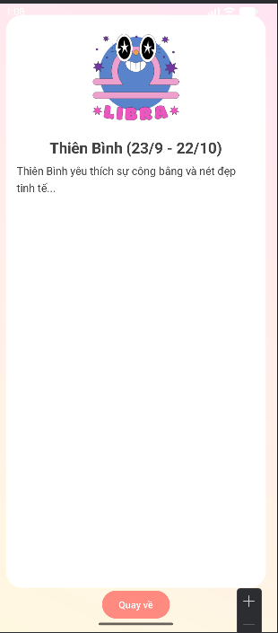

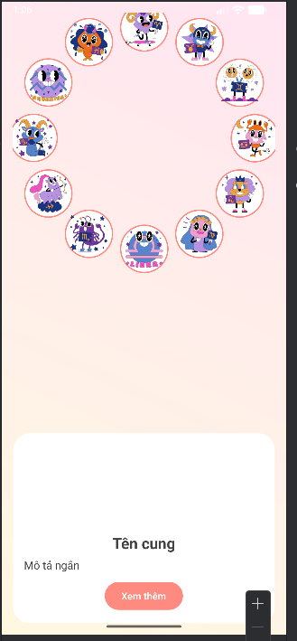 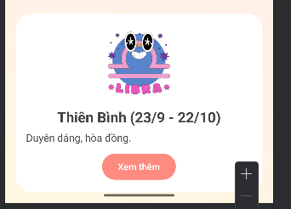

# BUỔI THỰC HÀNH 5

## BÀI 13+14

**Màn hình đăng nhập:**

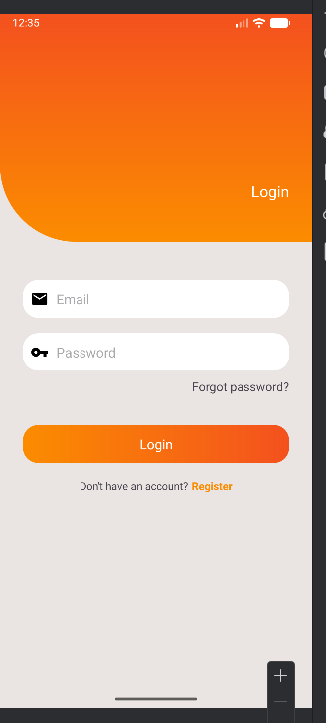

package com.example.lap05;

import android.content.Context;

import android.content.SharedPreferences;

import android.os.Bundle;

import android.view.*;

import android.widget.EditText;

import android.widget.Toast;

import androidx.fragment.app.Fragment;

public class M000LoginFragment extends Fragment implements View.OnClickListener {

private EditText edtEmail, edtPass;

private Context mContext;

@Override

public View onCreateView(LayoutInflater inflater, ViewGroup container,

Bundle savedInstanceState) {

View root = inflater.inflate(R.layout.m000_frg_login, container, false);

initView(root);

return root;

}

@Override

public void onAttach(Context context) {

super.onAttach(context);

mContext = context;

}

private void initView(View v) {

edtEmail = v.findViewById(R.id.edt_email);

edtPass = v.findViewById(R.id.edt_pass);

v.findViewById(R.id.tv_login).setOnClickListener(this);

v.findViewById(R.id.tv_register).setOnClickListener(this);

}

@Override

public void onClick(View v) {

if (v.getId() == R.id.tv_login) {

login();

} else if (v.getId() == R.id.tv_register) {

((MainActivity) mContext).gotoRegisterScreen();

}

}

private void login() {

String email = edtEmail.getText().toString().trim();

String pass = edtPass.getText().toString().trim();

**// 1. Kiểm tra giá trị rỗng**

if (email.isEmpty() || pass.isEmpty()) {

Toast.makeText(mContext, "Empty value", Toast.LENGTH_SHORT).show();

return;

}

**// 2. Lấy SharedPreferences để đọc dữ liệu đã lưu**

SharedPreferences pref = mContext.getSharedPreferences(

MainActivity.SAVE_PREF, Context.MODE_PRIVATE);

**// 3. Lấy password đã lưu theo email**

String savedPass = pref.getString(email, null);

**// 4. Kiểm tra email có tồn tại hay không**

if (savedPass == null) {

Toast.makeText(mContext, "Email is not existed!", Toast.LENGTH_SHORT).show();

return;

}

**// 5. Kiểm tra password đúng hay không**

if (!savedPass.equals(pass)) {

Toast.makeText(mContext, "Password is not correct!", Toast.LENGTH_SHORT).show();

return;

}

**// 6. Lưu trạng thái đăng nhập**

pref.edit().putBoolean("IS_LOGGED_IN", true).apply();

**// 7. Thông báo thành công**

Toast.makeText(mContext, "Login successfully!", Toast.LENGTH_SHORT).show();

**// 8. Chuyển màn hình (nếu muốn)**

// ((MainActivity)mContext).gotoHomeScreen();

}

}

**Đăng ký:**

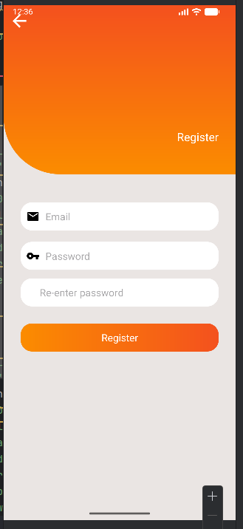

package com.example.lap05;

import android.content.Context;

import android.content.SharedPreferences;

import android.os.Bundle;

import android.view.*;

import android.widget.EditText;

import android.widget.Toast;

import androidx.fragment.app.Fragment;

public class M001RegisterFragment extends Fragment implements View.OnClickListener {

private EditText edtEmail, edtPass, edtRepass;

private Context mContext;

@Override

public View onCreateView(LayoutInflater inflater, ViewGroup container,

Bundle savedInstanceState) {

View root = inflater.inflate(R.layout.m001_frg_register, container, false);

initView(root);

return root;

}

@Override

public void onAttach(Context context) {

super.onAttach(context);

mContext = context;

}

private void initView(View v) {

edtEmail = v.findViewById(R.id.edt_email);

edtPass = v.findViewById(R.id.edt_pass);

edtRepass = v.findViewById(R.id.edt_re_pass);

**// 2 nút: back & register**

v.findViewById(R.id.iv_back).setOnClickListener(this);

v.findViewById(R.id.tv_register).setOnClickListener(this);

}

@Override

public void onClick(View v) {

if (v.getId() == R.id.iv_back) {

// Quay lại màn hình Login

((MainActivity) mContext).gotoLoginScreen();

} else if (v.getId() == R.id.tv_register) {

register();

}

}

private void register() {

String email = edtEmail.getText().toString().trim();

String pass = edtPass.getText().toString().trim();

String repass = edtRepass.getText().toString().trim();

**// 1. Kiểm tra dữ liệu trống**

if (email.isEmpty() || pass.isEmpty() || repass.isEmpty()) {

Toast.makeText(mContext, "Empty value", Toast.LENGTH_SHORT).show();

return;

}

**// 2. Kiểm tra password nhập lại**

if (!pass.equals(repass)) {

Toast.makeText(mContext, "Password is not match!", Toast.LENGTH_SHORT).show();

return;

}

**// 3. Lấy SharedPreferences để lưu tài khoản**

SharedPreferences pref = mContext.getSharedPreferences(

MainActivity.SAVE_PREF, Context.MODE_PRIVATE);

**// 4. Kiểm tra email đã tồn tại chưa**

String savedPass = pref.getString(email, null);

if (savedPass != null) {

Toast.makeText(mContext, "Email is existed!", Toast.LENGTH_SHORT).show();

return;

}

**// 5. Lưu tài khoản mới**

pref.edit()

.putString(email, pass) // Lưu email & password

.apply();

Toast.makeText(mContext, "Register successfully!", Toast.LENGTH_SHORT).show();

**// 6. Chuyển về màn Login**

((MainActivity) mContext).gotoLoginScreen();

}

}

**Kết quả**

